## **Project “Save the planet” Art Direction Concept Document**

Philosophy of this particular Art Direction:

* Describe what is important for your game in terms of how it looks. For example, dark and moody or bright and happy; minimalist or hyper-realistic or cartoony or some other quality that is important.
* Describe how the player interacts with the environment. For example, the camera will be zoomed out so everything needs to be exaggerated or the game is 1st person camera so textures need to be high detail.
* What is a phrase to describe the overall direction? For example, “Oppressed Medieval with a hint of hope” or “post-apocalyptic wasteland full of despair and misery”.
* What are some examples of the most important elements in your game. For example, beautiful forests with amazing views or constant explosions like in a war zone.

## Summary of Art Direction

This camera, lighting, perspective, overall feel....

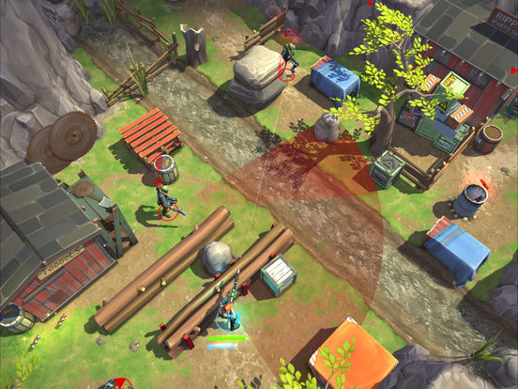

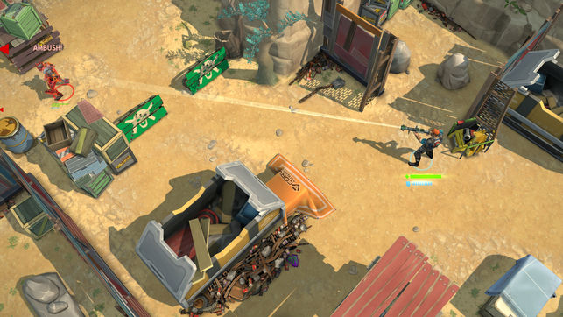

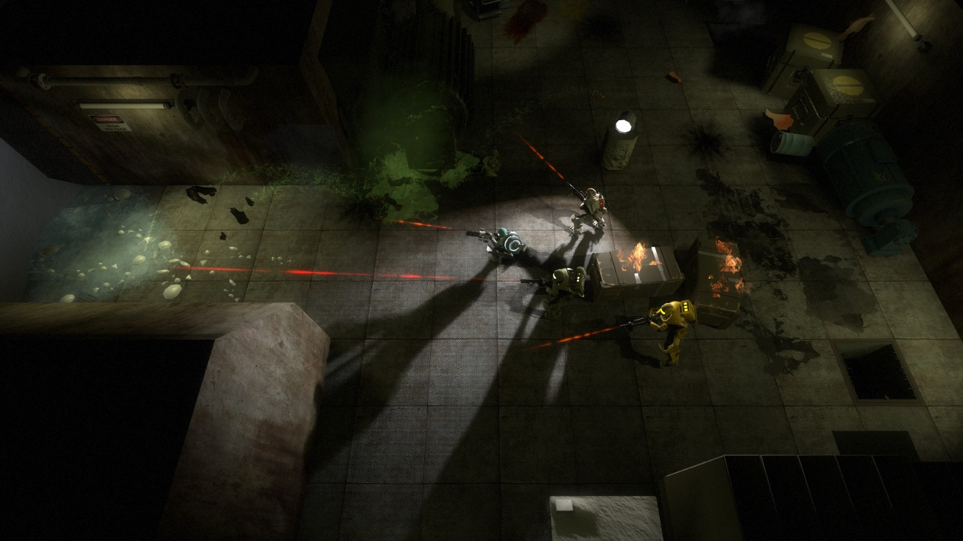

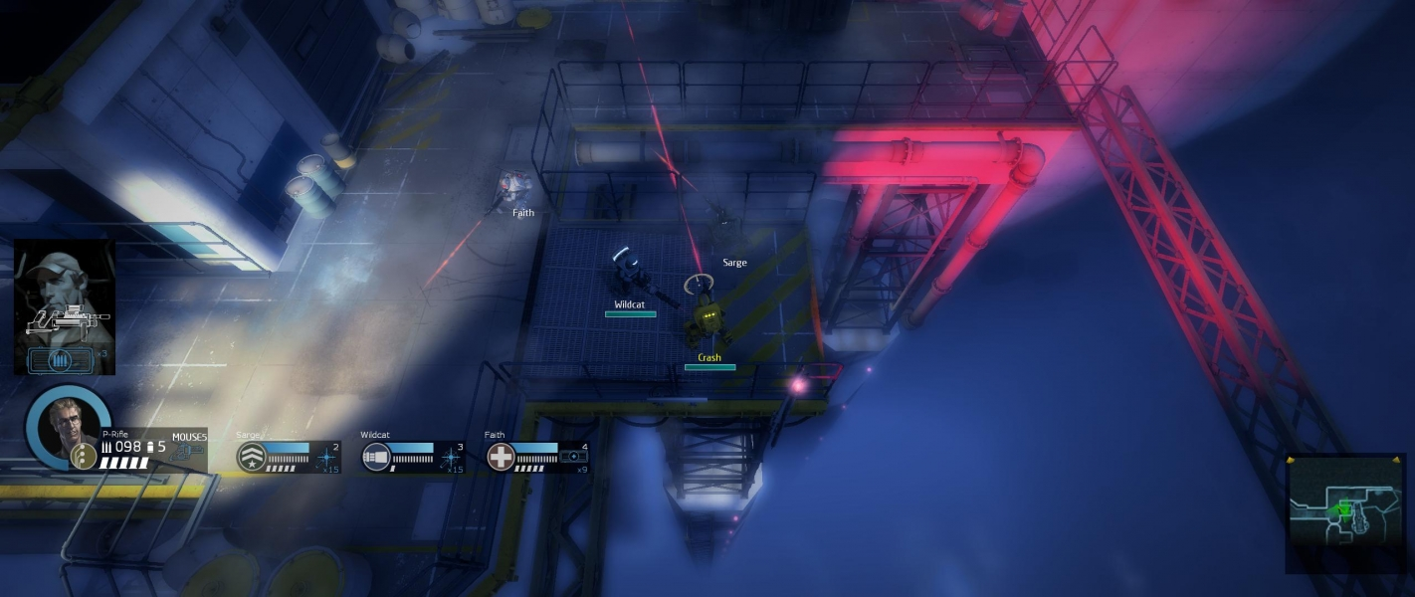

|  |  |
| --- | --- |
|  |  |

With these images of characters, enemies, people, monsters…

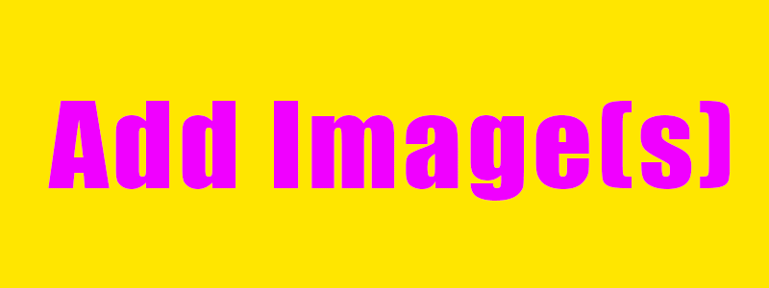

In these settings / locations…



With this sort of polish / effects…

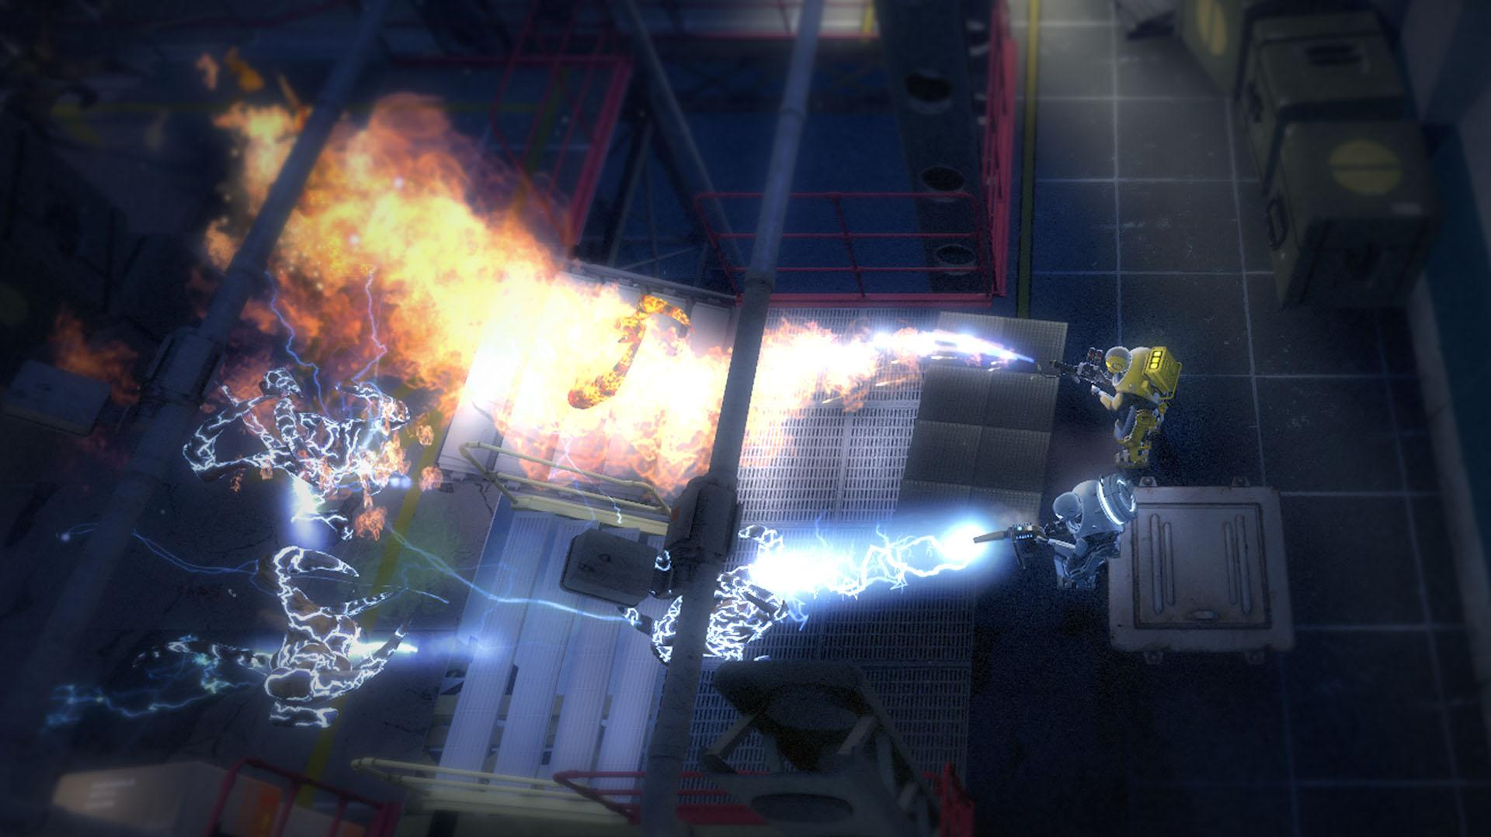

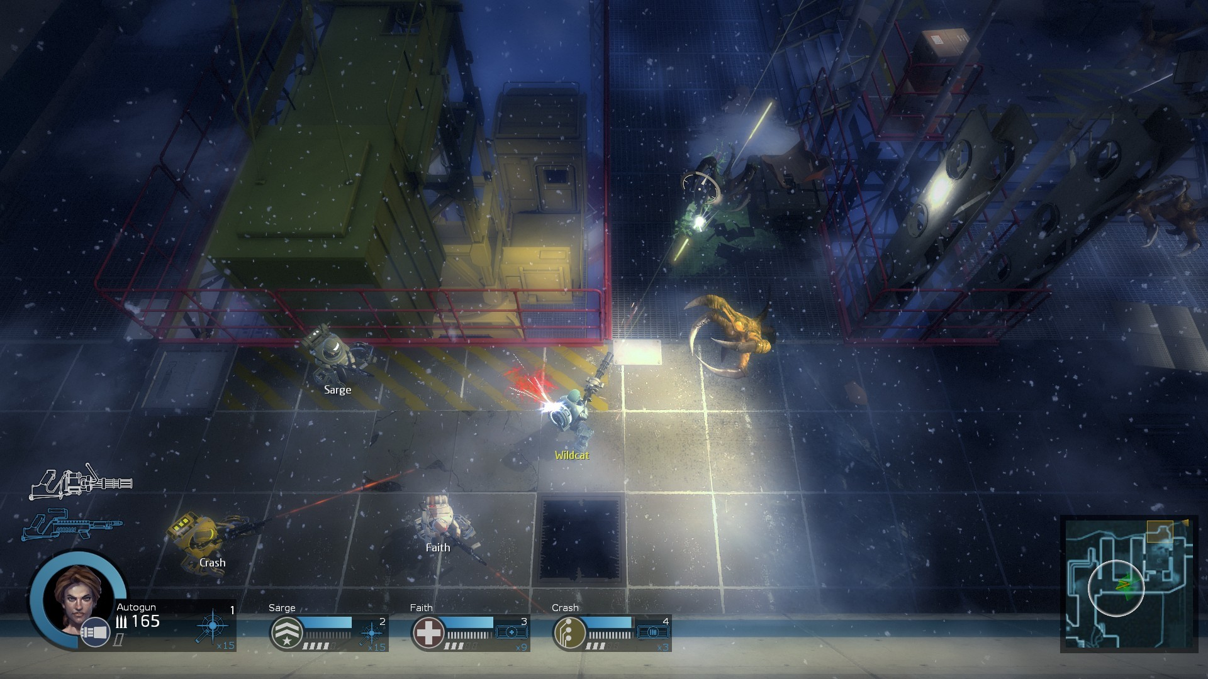

With this type of colour palette…



# More Detailed Explanation



If useful, go through some of the images you that found and particularly liked, highlighting what aspects you like. Eg. the shape of a building, the clothes of a character, the lighting of a room and so on.

You might have 3 images in this section, you might have 30 - put in as many as is useful to yourself or to an artist who might be working on the project with you.